Web plan
White Water Rafting
Thami Mnyandu
WDD 130

Overview
Purpose
The purpose of this website is to provide easier access to equipment. The purpose of my white water rafting website is to provide visitors with clear and exciting information about rafting adventures. It aims to showcase different rafting routes, difficulty levels, and safety guidelines so that users can choose the experience that best suits them. The website also helps people learn what to expect on a trip, what gear they may need, and how to prepare for a safe and enjoyable adventure on the water.
Audience
People who want to view the beautiful bodies of water and have the best experience on the water

Branding

Website Logo
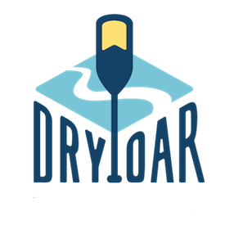

Style Guide
Color Palette
Primary | Secondary | Accent 1 | Accent 2
Typography
Heading Font: [.ttf]
Paragraph Font: [Font Name here]
Normal paragraph example
The best Whitewater Rafting in Colorado, White Water Rafting Company offers rafting on the Colorado and Roaring Fork Rivers in Glenwood Springs. Since 1974, we have been family owned and operated, rafting the Shoshone section of Glenwood Canyon and beyond.
Colored paragraph example
Trips vary from mild and great for families, to trips exclusively for physically fit and experienced rafters. No matter what type of river adventures you are seeking, White Water Rafting Company can make it happen for you.
Navigation with Hover
HomePage2Contact Us

Site Map
Home
[Page2]
Contact Us

Wireframes
Home
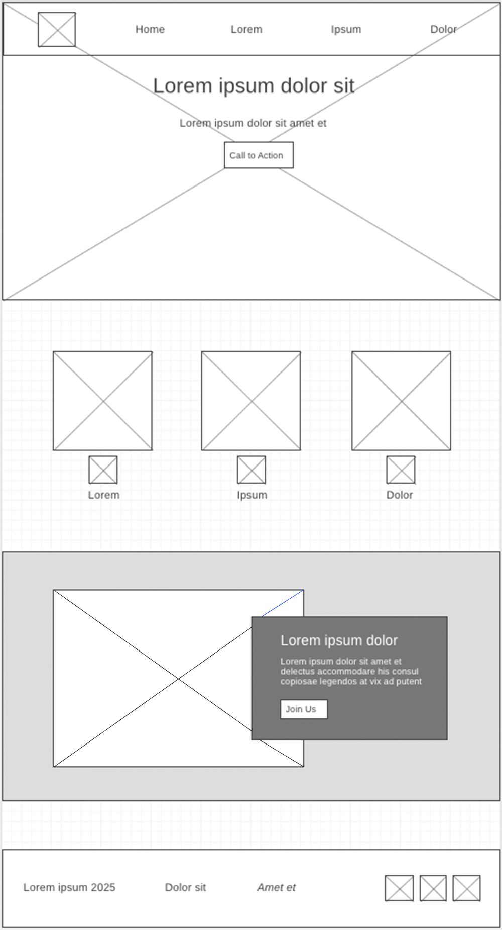
[Page 2]

